Chapter 4, Problem 52.

For the transistor model in Fig. 4.118, obtain the Thevenin equivalent at terminals a-b.

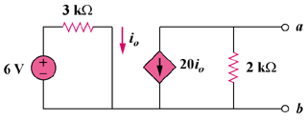
12 V

Figure 4.118
For Prob. 4.52.

